**DAILY ONLINE ACTIVITIES SUMMARY**

|  |  |  |  |  |  |  |  |  |
| --- | --- | --- | --- | --- | --- | --- | --- | --- |
| **Date:** | **29-06-2020** | | | | | **Name:** | **Sinchana** | |
| **Sem & Sec** | **6 B** | | | | | **USN:** | **4AL17CS117** | |
| **Online Test Summary** | | | | | | | | |
| **Subject** | | **Cyber Security**  **DBMS** | | | | | | |
| **Max. Marks** | |  | | **Score** | | |  | |
| **Certification Course Summary** | | | | | | | | |
| **Course** | Cyber securityData structures | | | | | | | |
| **Certificate Provider** | | | **Dr.Manjunath**  **Mrs.Reena Lobo** | | **Duration** | | | **4 hrs** |
| **Coding Challenges** | | | | | | | | |
| **Problem Statement: 1.centroid** | | | | | | | | |
| **Status: Success** | | | | | | | | |
| **Uploaded the report in Github** | | | | | **Yes** | | | |
| **If yes Repository name** | | | | | **coding** | | | |
| **Uploaded the report in slack** | | | | | **Yes** | | | |

Online Test Details: (Attach the snapshot and briefly write the report for the same)

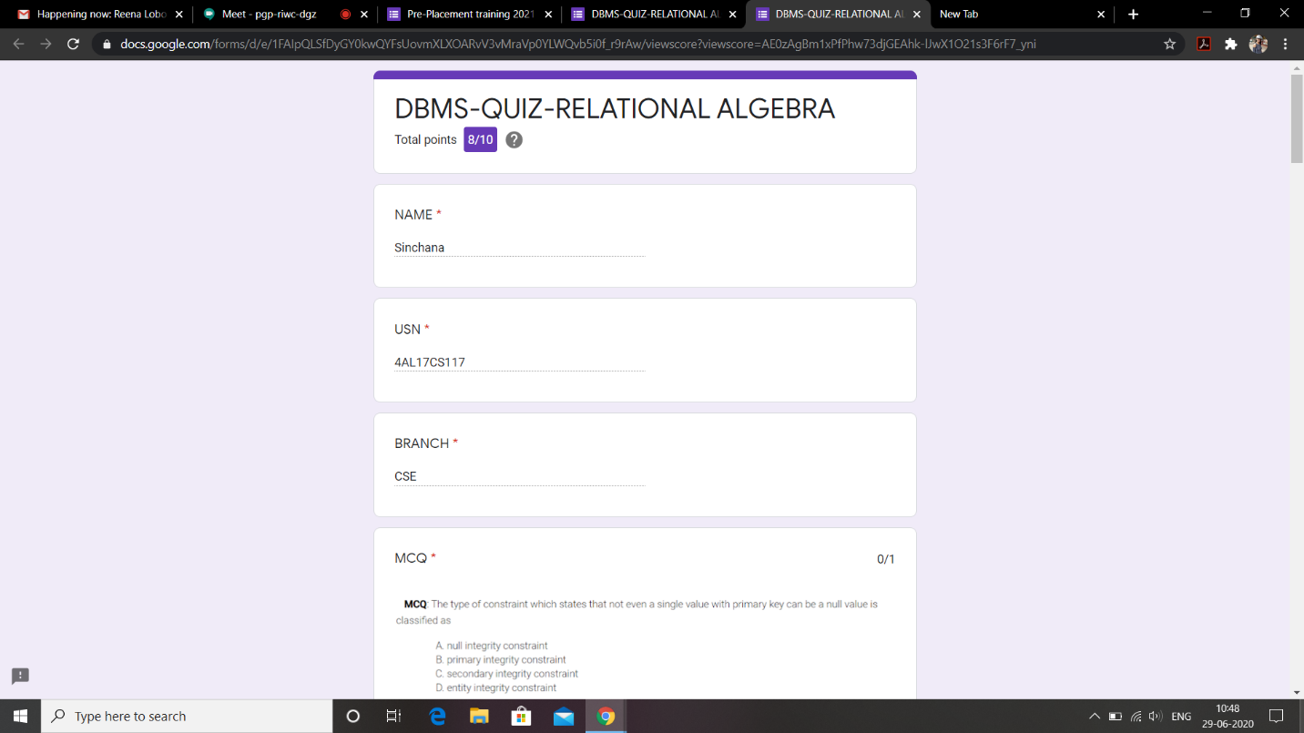

This is the response DBMS test and this is the snapshot of this.

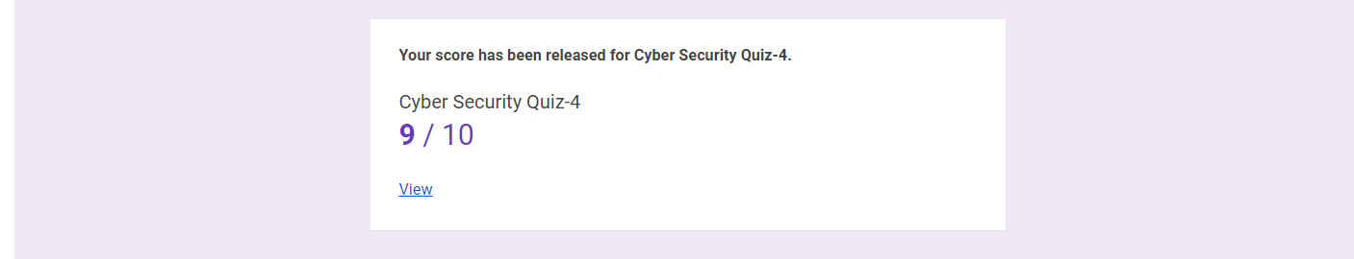

This is the response Cyber Security programming test and this is the snapshot of this.

Certification Course Details: (Attach the snapshot and briefly write the report for the same)

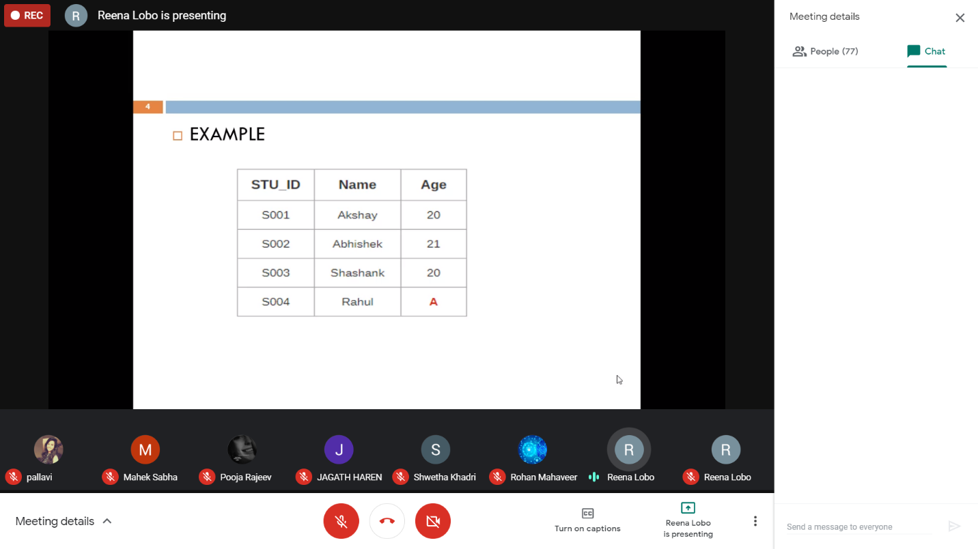

Today I have learnt about DBMS in which there where several examples where explained.

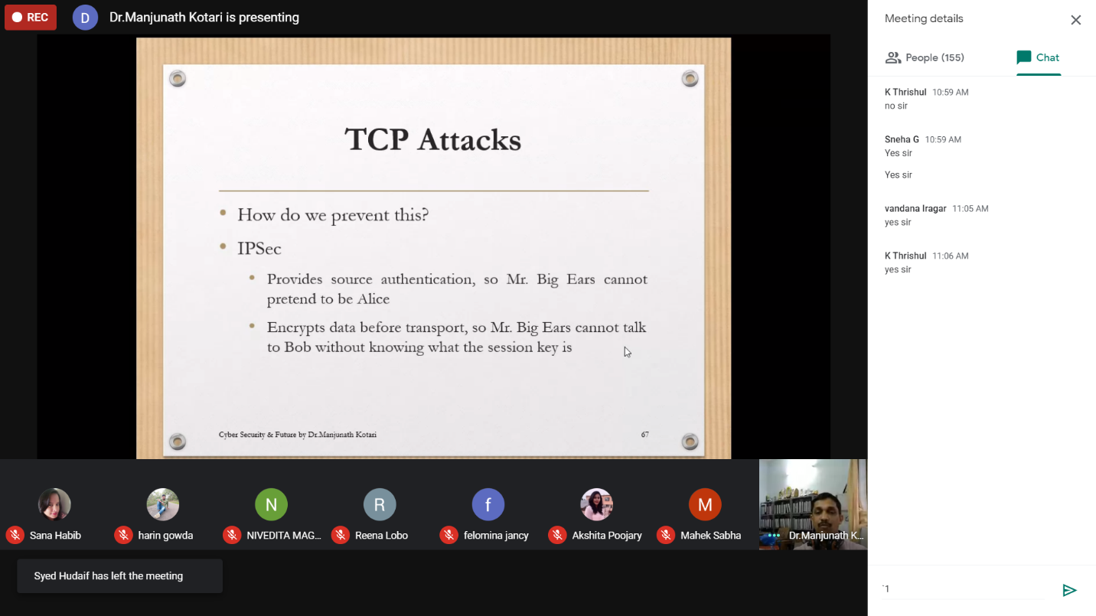

Today I have learnt about Cyber Security and several examples where explained.

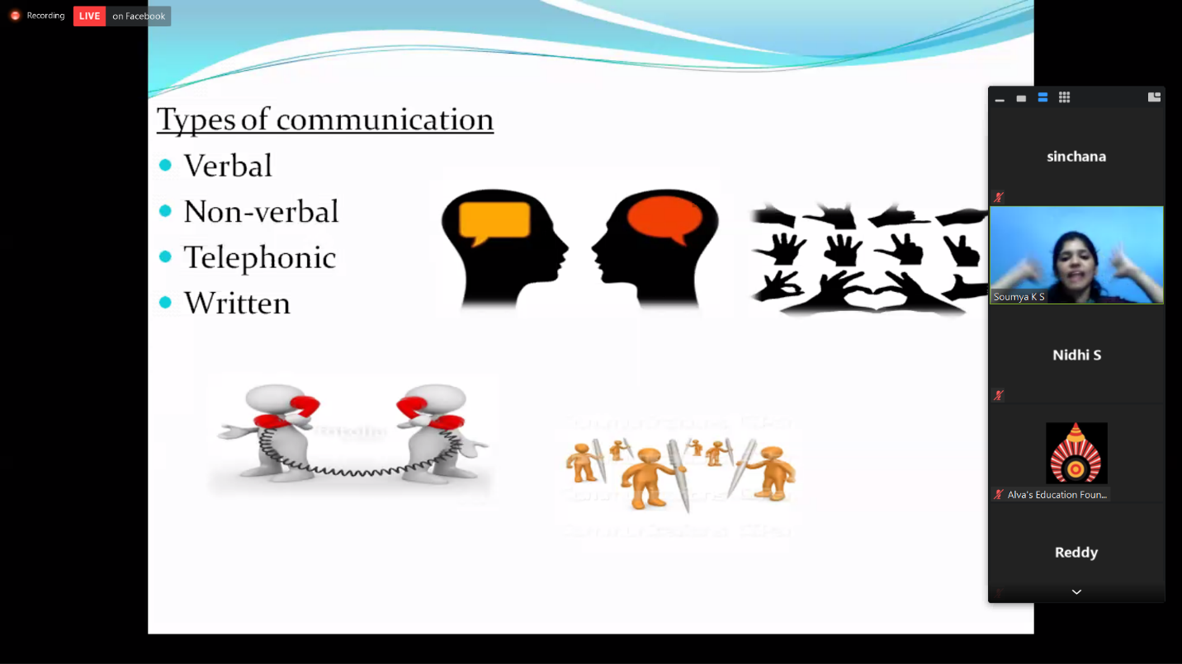

This is the snap shot of the today’s webinar.

Coding Challenges Details: (Attach the snapshot and briefly write the report for the same)

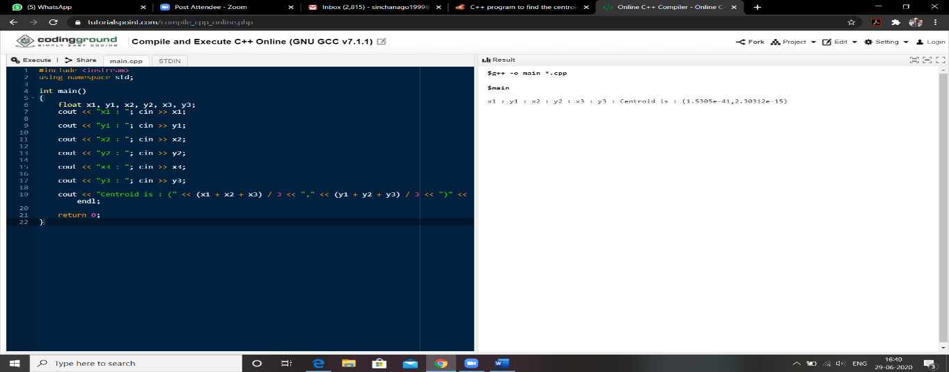

Link in Github :

1. Coding and Word document

<https://github.com/sinchana514/coding/tree/master/29th%20june>